# 7. PREDICTING DIABETES

|  |  |
| --- | --- |
| **EX.N0 : 7** | **PREDICTING DIABETES** |
| **DATE : 11/09/2024** |

**PROBLEM STATEMENT:** Predict the onset of diabetes based on medical measurements.

**PYTHON CONCEPTS:** Data structures, numeric types, functions.

**VISUALIZATION:** Scatter plots, heatmaps.

**MULTIVARIATE ANALYSIS:** Logistic regression, LDA.

**DATASET:** Pima Indians Diabetes Database **ALGORITHM:**

Step 1: Start the program.

Step 2: Import necessary libraries.

Step 3: Load the dataset.

Step 4: Encode categorical variable, define feature & testing set.

Step 5: Split the dataset into training & testing set, create trained model.

Step 6: Print equal metric & test the cell.

**PROGRAM:**

import pandas as pd import seaborn as sns import matplotlib.pyplot as plt from sklearn.model_selection import train_test_split from sklearn.linear_model import LogisticRegression from sklearn.metrics import classification_report, confusion_matrix, accuracy_score url = https://raw.githubusercontent.com/jbrownlee/Datasets/master/pima-indians-diabetes.data.csv

columns = ['Pregnancies', 'Glucose', 'BloodPressure', 'SkinThickness', 'Insulin', 'BMI', 'DiabetesPedigreeFunction', 'Age', 'Outcome']

data = pd.read_csv(url, header=None, names=columns) print("First 5 records:\n", data.head()) print("\nStatistical Summary:\n", data.describe()) print("\nDataset Info:\n") print(data.info()) sns.pairplot(data, hue='Outcome') plt.show() correlation_matrix = data.corr() plt.figure(figsize=(10, 8)) sns.heatmap(correlation_matrix, annot=True, cmap='coolwarm') plt.show()

X = data.drop('Outcome', axis=1) y = data['Outcome']

X_train, X_test, y_train, y_test = train_test_split(X, y, test_size=0.3, random_state=42) model = LogisticRegression(max_iter=1000) model.fit(X_train, y_train) y_pred = model.predict(X_test) print("Confusion Matrix:") print(confusion_matrix(y_test, y_pred)) print("\nClassification Report:") print(classification_report(y_test, y_pred)) accuracy = accuracy_score(y_test, y_pred) print(f"\nModel Accuracy: {accuracy * 100:.2f}%") sample = X_test.iloc[0].values.reshape(1, -1) sample_prediction = model.predict(sample) print(f"\nPrediction for sample case (1 = Diabetes, 0 = No Diabetes): {sample_prediction[0]}") **OUTPUT:**

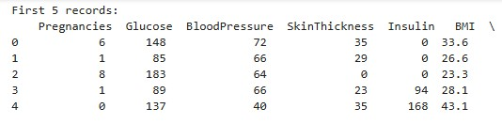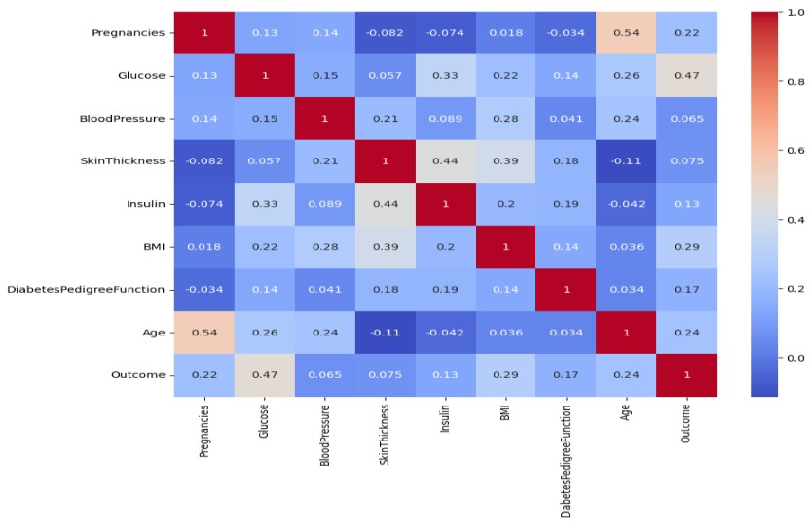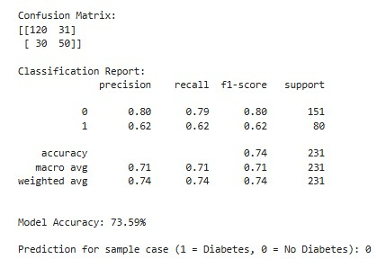

**RESULT:**

Thus, the program for predicting diabetes is executed successfully.

# 8. WINE QUALITY PREDICTION

|  |  |
| --- | --- |
| **EX.N0 : 8** | **WINE QUALITY PREDICTION** |
| **DATE : 18/09/2024** |

**PROBLEM STATEMENT:** Predict the quality of wine based on various chemical properties.

**PYTHON CONCEPTS:** Classes, sequences, file handling.

**VISUALIZATION:** Histograms, box plots.

**MULTIVARIATE ANALYSIS:** Multiple regression, factor analysis.

**DATASET:** Wine Quality Dataset **ALGORITHM:**

Step 1: Start the program.

Step 2: Import necessary libraries.

Step 3: Load the dataset.

Step 4: Encode categorical variable, define feature & testing set.

Step 5: Split the dataset into training & testing set, create trained model.

Step 6: Print equal metric & test the cell.

**PROGRAM:**

import pandas as pd import numpy as np import matplotlib.pyplot as plt import seaborn as sns

from sklearn.model_selection import train_test_split from sklearn.linear_model import LinearRegression from sklearn.metrics import mean_squared_error, r2_score class WineQualityPredictor: def __init__(self, num_samples=1000):

self.num_samples = num_samples self.data = None self.model = None def generate_data(self): np.random.seed(42) quality = np.random.randint(3, 9, self.num_samples) # Quality scores between 3 and 8 fixed_acidity = np.random.uniform(4.6, 15.9, self.num_samples) volatile_acidity = np.random.uniform(0.12, 1.58, self.num_samples) citric_acid = np.random.uniform(0, 1, self.num_samples) residual_sugar = np.random.uniform(1.9, 15.5, self.num_samples) chlorides = np.random.uniform(0.012, 0.1, self.num_samples) free_sulfur_dioxide = np.random.uniform(1, 72, self.num_samples) total_sulfur_dioxide = np.random.uniform(6, 289, self.num_samples) density = np.random.uniform(0.99007, 1.00369, self.num_samples) pH = np.random.uniform(2.74, 4.01, self.num_samples) sulfur_dioxide = np.random.uniform(10, 60, self.num_samples) alcohol = np.random.uniform(8.0, 14.9, self.num_samples) self.data = pd.DataFrame({

'fixed acidity': fixed_acidity, 'volatile acidity': volatile_acidity, 'citric acid': citric_acid,

'residual sugar': residual_sugar, 'chlorides': chlorides, 'free sulfur dioxide': free_sulfur_dioxide,

'total sulfur dioxide': total_sulfur_dioxide, 'density': density, 'pH': pH, 'sulphur dioxide': sulfur_dioxide, 'alcohol': alcohol, 'quality': quality })

print(f"Synthetic Data Generated: {self.data.shape[0]} rows and {self.data.shape[1]} columns") def visualize_data(self):

self.data.hist(bins=15, figsize=(15, 10)) plt.suptitle('Histograms of Wine Quality Features') plt.show() plt.figure(figsize=(10, 6))

sns.boxplot(x='quality', y='fixed acidity', data=self.data) plt.title('Box Plot of Fixed Acidity by Quality') plt.show() def preprocess_data(self): X = self.data.drop('quality', axis=1) y = self.data['quality']

return X, y def train_model(self, X, y):

X_train, X_test, y_train, y_test = train_test_split(X, y, test_size=0.2, random_state=42) self.model = LinearRegression() self.model.fit(X_train, y_train) y_pred = self.model.predict(X_test) return y_train, y_test, y_pred def evaluate_model(self, y_test, y_pred): mse = mean_squared_error(y_test, y_pred) r2 = r2_score(y_test, y_pred) print(f'Mean Squared Error: {mse}') print(f'R^2 Score: {r2}') def predict_quality(self, input_features):

input_df = pd.DataFrame([input_features], columns=self.data.columns[:-1]) prediction = self.model.predict(input_df) return prediction[0] def run(self): self.generate_data() self.visualize_data() X, y = self.preprocess_data() y_train, y_test, y_pred = self.train_model(X, y) self.evaluate_model(y_test, y_pred) if __name__ == "__main__":

wine_predictor = WineQualityPredictor(num_samples=1000) wine_predictor.run() example_features = {

'fixed acidity': 7.4, 'volatile acidity': 0.7, 'citric acid': 0.0,

'residual sugar': 1.9, 'chlorides': 0.076, 'free sulfur dioxide': 11.0,

'total sulfur dioxide': 34.0, 'density': 0.9978, 'pH': 3.51,

'sulphur dioxide': 45.0, 'alcohol': 9.4 } predicted_quality = wine_predictor.predict_quality(example_features) print(f'Predicted Wine Quality: {predicted_quality:.2f}')

**OUTPUT:**

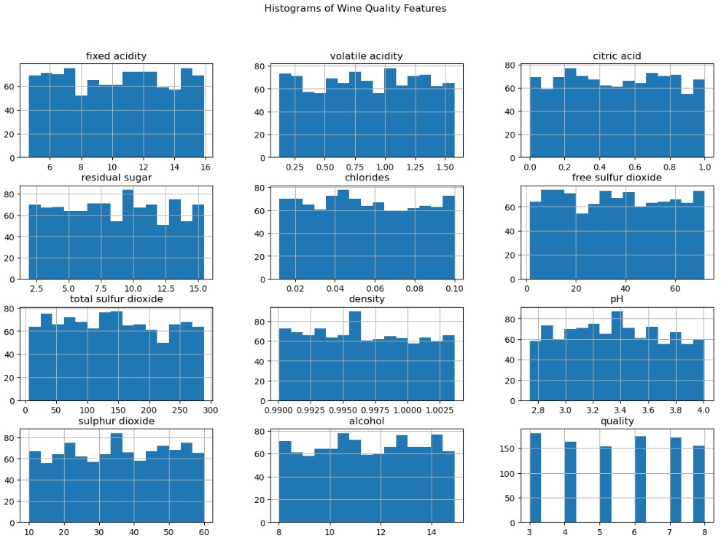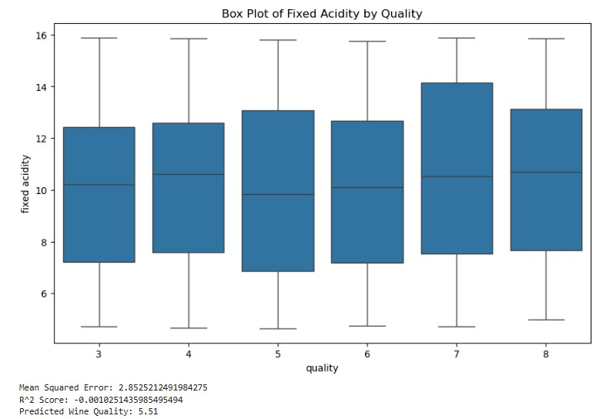

**RESULT:**

Thus, the program for wine quality prediction is executed successfully.

**9. HEART DISEASE PREDICTION**

|  |  |
| --- | --- |
| **EX.N0 : 9** | **HEART DISEASE PREDICTION** |
| **DATE : 07/10/2024** |

**PROBLEM STATEMENT:** Predict heart disease based on clinical parameters **PYTHON CONCEPTS:** Functions, data structures.

**VISUALIZATION:** Pair plots, ROC curve.

**MULTIVARIATE ANALYSIS:** Logistic regression, PCA.

**DATASET:** Heart Disease Dataset **ALGORITHM:**

Step 1: Start the program.

Step 2: Import necessary libraries.

Step 3: Load the dataset.

Step 4: Encode categorical variable, define feature & testing set.

Step 5: Split the dataset into training & testing set, create trained model.

Step 6: Print equal metric & test the cell.

**PROGRAM:**

import numpy as np import pandas as pd import matplotlib.pyplot as plt import seaborn as sns

from sklearn.model_selection import train_test_split from sklearn.preprocessing import StandardScaler from sklearn.linear_model import LogisticRegression from sklearn.metrics import accuracy_score, confusion_matrix, classification_report np.random.seed(42) # For reproducibility num_samples = 1000 age = np.random.randint(30, 80, num_samples) sex = np.random.randint(0, 2, num_samples) cp = np.random.randint(0, 4, num_samples) trestbps = np.random.randint(90, 200, num_samples) chol = np.random.randint(150, 300, num_samples) fbs = np.random.randint(0, 2, num_samples) restecg = np.random.randint(0, 2, num_samples) thalach = np.random.randint(60, 200, num_samples) exang = np.random.randint(0, 2, num_samples) oldpeak = np.random.uniform(0, 6, num_samples) slope = np.random.randint(0, 3, num_samples) ca = np.random.randint(0, 4, num_samples) thal = np.random.randint(1, 4, num_samples) target = np.random.randint(0, 2, num_samples) data = pd.DataFrame({

'age': age, 'sex': sex, 'cp': cp,

'trestbps': trestbps, 'chol': chol,

'fbs': fbs, 'restecg': restecg, 'thalach': thalach, 'exang': exang,

'oldpeak': oldpeak, 'slope': slope, 'ca': ca,

'thal': thal, 'target': target})

X = data.drop('target', axis=1) y = data['target']

X_train, X_test, y_train, y_test = train_test_split(X, y, test_size=0.2, random_state=42) scaler = StandardScaler()

X_train = scaler.fit_transform(X_train) X_test = scaler.transform(X_test) model = LogisticRegression() model.fit(X_train, y_train) y_pred = model.predict(X_test) accuracy = accuracy_score(y_test, y_pred) conf_matrix = confusion_matrix(y_test, y_pred) class_report = classification_report(y_test, y_pred) print(f'Accuracy: {accuracy:.2f}') print('Confusion Matrix:') print(conf_matrix) print('Classification Report:') print(class_report) plt.figure(figsize=(8, 6)) sns.heatmap(conf_matrix, annot=True, fmt='d', cmap='Blues', xticklabels=['No Disease',

'Disease'], yticklabels=['No Disease', 'Disease']) plt.title('Confusion Matrix') plt.xlabel('Predicted') plt.ylabel('Actual') plt.show() importance = model.coef_[0] features = X.columns importance_df = pd.DataFrame({'Feature': features, 'Importance': importance}) importance_df = importance_df.sort_values(by='Importance', ascending=False) plt.figure(figsize=(10, 6)) sns.barplot(data=importance_df, x='Importance', y='Feature', palette='viridis') plt.title('Feature Importance') plt.xlabel('Coefficient Value') plt.ylabel('Features') plt.axvline(0, color='red', linestyle='--') # Adding a vertical line at 0 plt.show()

**OUTPUT:**

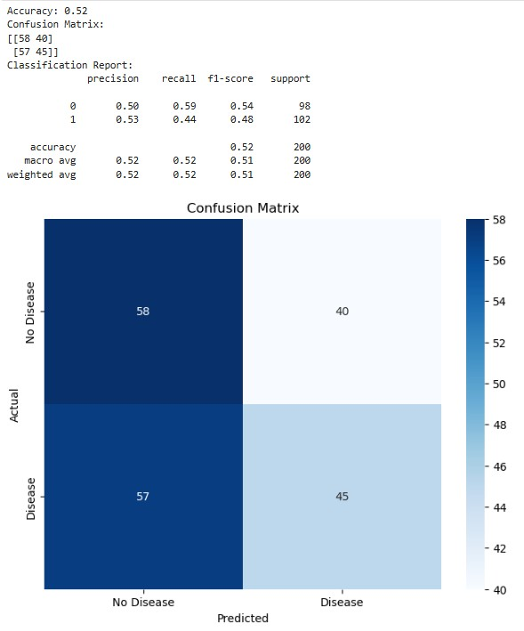

**RESULT:**

Thus, the program for heart disease prediction is executed successfully.

# 10. BREAST CANCER DIAGNOSIS

|  |  |
| --- | --- |
| **EX.N0 : 10** | **Breast Cancer Diagnosis** |
| **DATE : 09/10/2024** |

**PROBLEM STATEMENT:** Classify tumors as benign or malignant based on features.

**PYTHON CONCEPTS:** Classes, sequences.

**VISUALIZATION:** Confusion matrix, bar plots.

**MULTIVARIATE ANALYSIS:** LDA, logistic regression.

**DATASET:** Breast Cancer Wisconsin Dataset **ALGORITHM:**

Step 1: Start the program.

Step 2: Import necessary libraries.

Step 3: Load the dataset.

Step 4: Encode categorical variable, define feature & testing set.

Step 5: Split the dataset into training & testing set, create trained model.

Step 6: Print equal metric & test the cell.

**PROGRAM:**

import numpy as np import pandas as pd import matplotlib.pyplot as plt import seaborn as sns

from sklearn.model_selection import train_test_split from sklearn.preprocessing import StandardScaler from sklearn.linear_model import LogisticRegression from sklearn.metrics import accuracy_score, confusion_matrix, classification_report np.random.seed(42) # For reproducibility num_samples = 1000 age = np.random.randint(30, 80, num_samples) sex = np.random.randint(0, 2, num_samples) cp = np.random.randint(0, 4, num_samples) trestbps = np.random.randint(90, 200, num_samples) chol = np.random.randint(150, 300, num_samples) fbs = np.random.randint(0, 2, num_samples) restecg = np.random.randint(0, 2, num_samples) thalach = np.random.randint(60, 200, num_samples) exang = np.random.randint(0, 2, num_samples) oldpeak = np.random.uniform(0, 6, num_samples) slope = np.random.randint(0, 3, num_samples) ca = np.random.randint(0, 4, num_samples) thal = np.random.randint(1, 4, num_samples) target = np.random.randint(0, 2, num_samples) data = pd.DataFrame({

'age': age, 'sex': sex, 'cp': cp,

'trestbps': trestbps, 'chol': chol,

'fbs': fbs, 'restecg': restecg, 'thalach': thalach, 'exang': exang,

'oldpeak': oldpeak, 'slope': slope, 'ca': ca,

'thal': thal, 'target': target})

X = data.drop('target', axis=1) y = data['target']

X_train, X_test, y_train, y_test = train_test_split(X, y, test_size=0.2, random_state=42) scaler = StandardScaler()

X_train = scaler.fit_transform(X_train) X_test = scaler.transform(X_test) model = LogisticRegression() model.fit(X_train, y_train) y_pred = model.predict(X_test) accuracy = accuracy_score(y_test, y_pred) conf_matrix = confusion_matrix(y_test, y_pred) class_report = classification_report(y_test, y_pred) print(f'Accuracy: {accuracy:.2f}') print('Confusion Matrix:') print(conf_matrix) print('Classification Report:') print(class_report) plt.figure(figsize=(8, 6)) sns.heatmap(conf_matrix, annot=True, fmt='d', cmap='Blues', xticklabels=['No Disease',

'Disease'], yticklabels=['No Disease', 'Disease']) plt.title('Confusion Matrix') plt.xlabel('Predicted') plt.ylabel('Actual') plt.show() importance = model.coef_[0] features = X.columns importance_df = pd.DataFrame({'Feature': features, 'Importance': importance}) importance_df = importance_df.sort_values(by='Importance', ascending=False) plt.figure(figsize=(10, 6)) sns.barplot(data=importance_df, x='Importance', y='Feature', palette='viridis') plt.title('Feature Importance') plt.xlabel('Coefficient Value') plt.ylabel('Features') plt.axvline(0, color='red', linestyle='--') # Adding a vertical line at 0 plt.show()

**OUTPUT:**

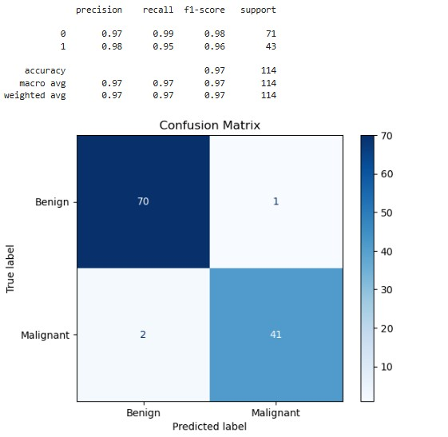

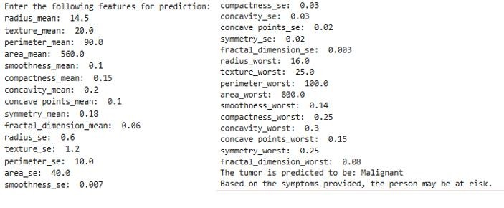

**RESULT:**

Thus, the program for breast cancer diagnosis is executed successfully.

**11. PREDICTING FLIGHT DELAYS**

|  |  |
| --- | --- |
| **EX.N0 : 11** | **PREDICTING FLIGHT DELAYS** |
| **DATE : 16/10/2024** |

**PROBLEM STATEMENT:** Predict flight delays based on historical data.

**PYTHON CONCEPTS:** File reading/writing, functions.

**VISUALIZATION:** Line plots, scatter plots.

**MULTIVARIATE ANALYSIS:** Regression, clustering.

**DATASET:** Flight Delay Dataset **ALGORITHM:**

Step 1: Start the program.

Step 2: Import necessary libraries.

Step 3: Load the dataset.

Step 4: Encode categorical variable, define feature & testing set.

Step 5: Split the dataset into training & testing set, create trained model.

Step 6: Print equal metric & test the cell.

**PROGRAM:**

import pandas as pd import numpy as np import matplotlib.pyplot as plt import seaborn as sns

from sklearn.model_selection import train_test_split from sklearn.linear_model import LinearRegression from sklearn.metrics import mean_absolute_error, mean_squared_error, r2_score df = pd.read_csv('C:/Users/APPU/Downloads/Airline_Delay_Cause.csv') print(df.columns) print(df.isnull().sum()) df.dropna(inplace=True) # or df.fillna(method='ffill', inplace=True) if 'year' in df.columns and 'month' in df.columns:

df['date'] = pd.to_datetime(df[['year', 'month']].assign(day=1)) plt.figure(figsize=(10, 5)) sns.lineplot(data=df, x='date', y='arr_delay') # Adjust if necessary plt.title('Flight Delays Over Time') plt.xticks(rotation=45) plt.show() delay_column = 'arr_delay' # Using 'arr_delay' for now if 'carrier_delay' in df.columns and delay_column in df.columns:

plt.figure(figsize=(10, 5)) sns.scatterplot(data=df, x='carrier_delay', y=delay_column) # Adjust as needed plt.title('Carrier Delay vs Arrival Delays') plt.xlabel('Carrier Delay (minutes)') plt.ylabel('Arrival Delay (minutes)') plt.show()

else: print("Check the delay columns: 'carrier_delay' or 'arr_delay' do not exist in the DataFrame.") df['day_of_week'] = df['date'].dt.dayofweek # Monday=0, Sunday=6 features = ['day_of_week', 'arr_flights', 'carrier_ct'] # Modify as needed

X = df[features] y = df[delay_column]

X_train, X_test, y_train, y_test = train_test_split(X, y, test_size=0.2, random_state=42) model = LinearRegression() model.fit(X_train, y_train) predictions = model.predict(X_test) print('Mean Absolute Error:', mean_absolute_error(y_test, predictions)) print('Mean Squared Error:', mean_squared_error(y_test, predictions)) print('R-squared:', r2_score(y_test, predictions)) plt.figure(figsize=(10, 5)) plt.scatter(y_test, predictions) plt.plot([min(y_test), max(y_test)], [min(y_test), max(y_test)], color='red', linewidth=2) # Line of equality plt.title('Predictions vs Actual Delays') plt.xlabel('Actual Delays') plt.ylabel('Predicted Delays') plt.show()

**OUTPUT:**

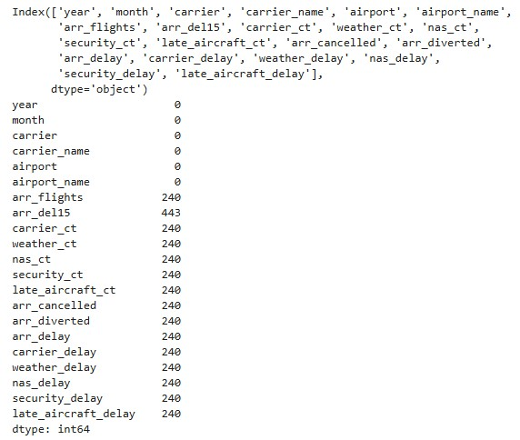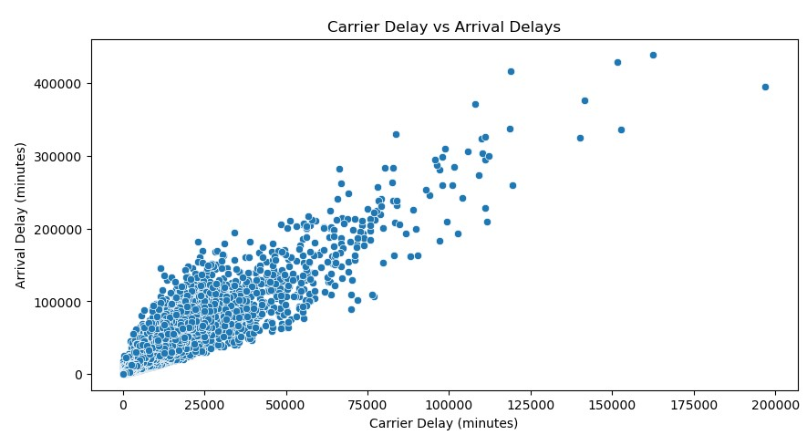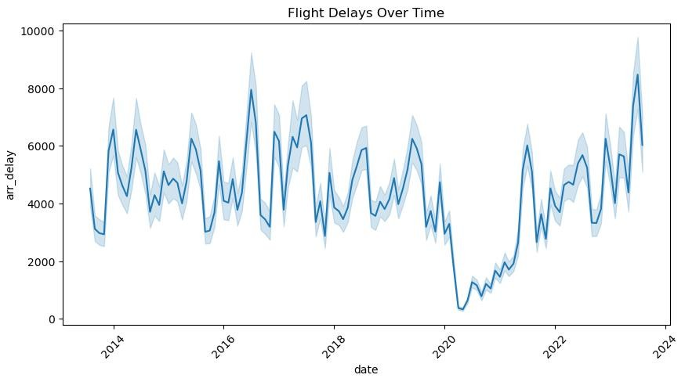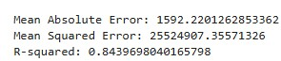

**RESULT:**

Thus, the program for predicting flight delays is executed successfully.

**12. ENERGY CONSUMPTION FORECASTING**

|  |  |
| --- | --- |
| **EX.N0 : 12** | **ENERGY CONSUMPTION FORECASTING** |
| **DATE : 23/10/2024** |

**PROBLEM STATEMENT:** Forecast energy consumption based on historical data.

**PYTHON CONCEPTS:** Functions, numeric types.

**VISUALIZATION:** Line plots, heatmaps.

**MULTIVARIATE ANALYSIS:** Time series analysis, regression.

**DATASET:** Energy Consumption Dataset **ALGORITHM:**

Step 1: Start the program.

Step 2: Import necessary libraries.

Step 3: Load the dataset.

Step 4: Encode categorical variable, define feature & testing set.

Step 5: Split the dataset into training & testing set, create trained model.

Step 6: Print equal metric & test the cell.

**PROGRAM:**

import pandas as pd import numpy as np import matplotlib.pyplot as plt import seaborn as sns

from statsmodels.tsa.arima.model import ARIMA from sklearn.metrics import mean_squared_error data = pd.read_csv('C:/Users/APPU/Downloads/energy_consumption_dataset.csv', parse_dates=['Timestamp'], index_col='Timestamp') print(data.head()) print(data.info())

data = data.fillna(method='ffill') plt.figure(figsize=(14, 6)) plt.plot(data['EnergyConsumption'], color='blue', label='Energy Consumption') plt.title('Energy Consumption Over Time') plt.xlabel('Date') plt.ylabel('Consumption') plt.legend() plt.show() numeric_data = data.select_dtypes(include=[np.number]) plt.figure(figsize=(10, 8)) sns.heatmap(numeric_data.corr(), annot=True, cmap='coolwarm') plt.title('Correlation Matrix') plt.show() from statsmodels.tsa.seasonal import seasonal_decompose result = seasonal_decompose(data['EnergyConsumption'], model='additive', period=24) # Adjust period based on your data's frequency result.plot() plt.show() train_size = int(len(data) * 0.8) train, test = data['EnergyConsumption'][:train_size], data['EnergyConsumption'][train_size:] model = ARIMA(train, order=(5, 1, 0)) # Adjust (p,d,q) based on your data's behavior fitted_model = model.fit() forecast = fitted_model.forecast(steps=len(test)) forecast_index = test.index mse = mean_squared_error(test, forecast) rmse = np.sqrt(mse) print(f'RMSE: {rmse}') plt.figure(figsize=(14, 6)) plt.plot(train, label='Train') plt.plot(test, label='Test') plt.plot(forecast_index, forecast, label='Forecast') plt.title('Energy Consumption Forecast') plt.xlabel('Date') plt.ylabel('Consumption') plt.legend() plt.show()

**OUTPUT:**

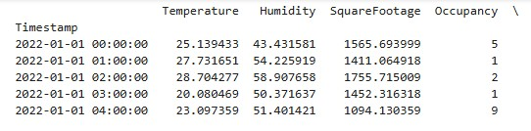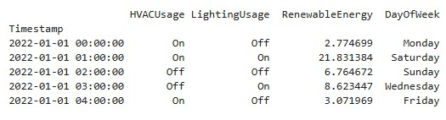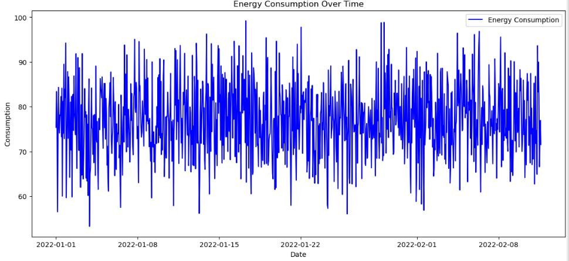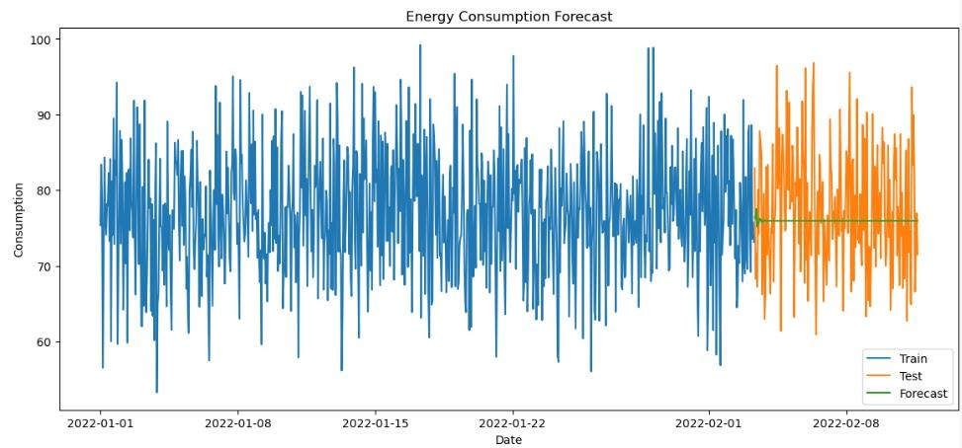

**RESULT:**

Thus, the program for energy consumption forecasting is executed successfully.